MEDICAL INVENTORY MANAGEMENT

**COLLEGE NAME:**  Shree Venkateshwara arts and science college

**COLLEGE CODE:** brubd

**TEAM ID:** NM2025TMID20962

**TEAM MEMBERS:**

**Team LeaderName:** Jessicka Florence.D

**Email:** jessickaflorence2023aids@gmail.com

**Team Member1:** Abinayasri.U

**Email:** abinayasriu2023aids@gmail.com

**Team Member2:**Mahalakshmi.S

**Email:** mahalakshmis2023aids@gmail.com

**Team Member3:** Manju Sri.T

**Email:** manjusrit2023aids

**Team Member4:**  Fathima

**Email:** fathimak2023aids@gmail.com

**1.INTRODUCTION:**

* 1. **Project Overview**

Effective inventory management is critical in healthcare settings to ensure the availability of essential medical supplies, equipment and pharmaceuticals. Medical inventory management involves tracking , storing and managing these resources to meet patient needs while minimizing waste, reducing costs and maintaining regulatory compliance.

* 1. **Purpose**

The primary purpose of Medical inventory management is to ensure the efficient and effective management of medical supplies, equipment and pharmaceuticals in healthcare settings.

DEVELOPMENT PHASE:

* Creating developer account.



* Creating a product object.

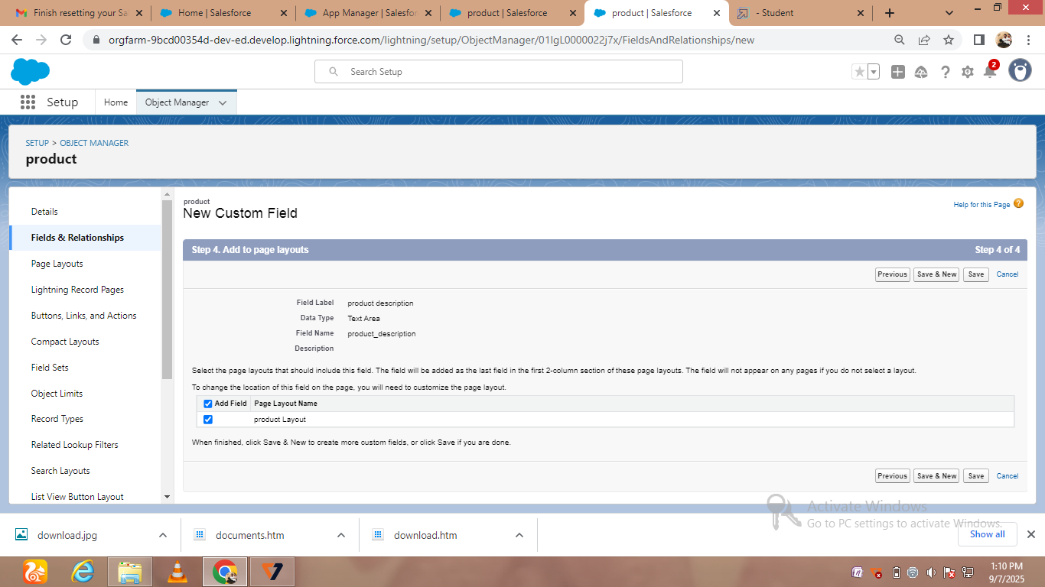

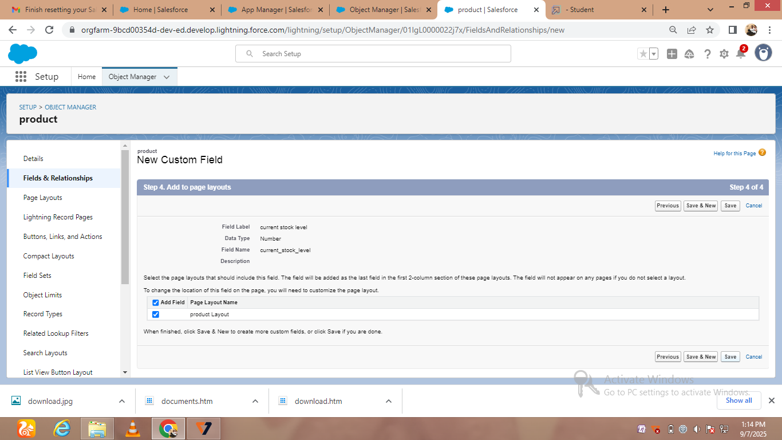

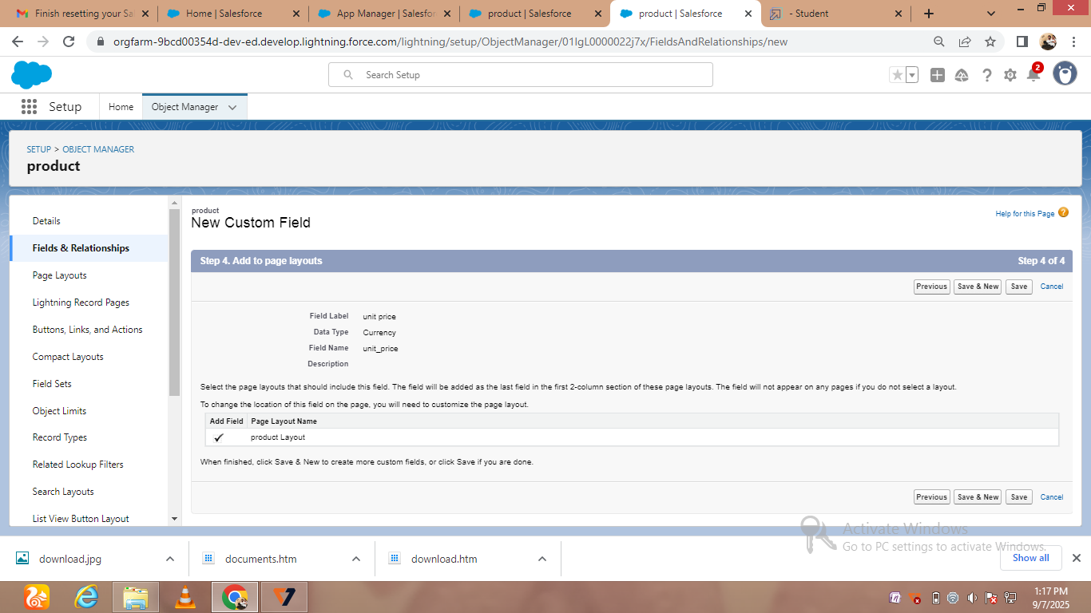

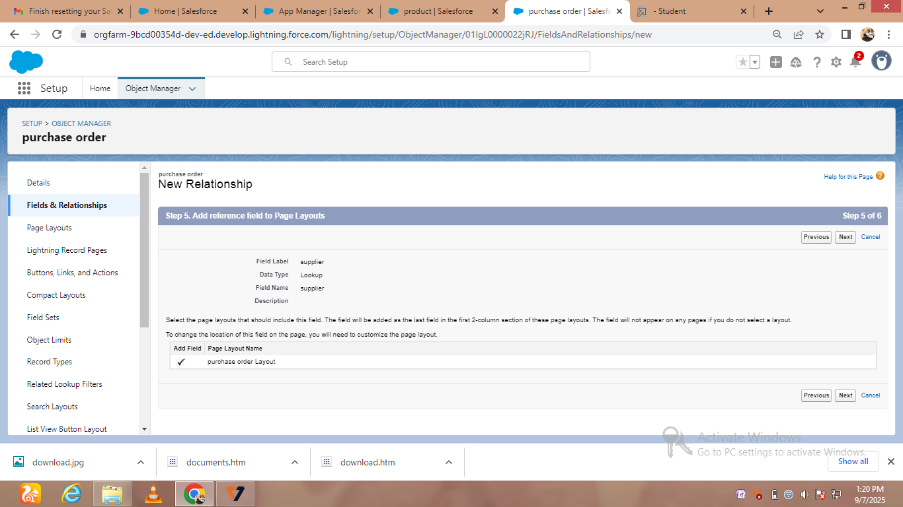

* Creating new Custom field id

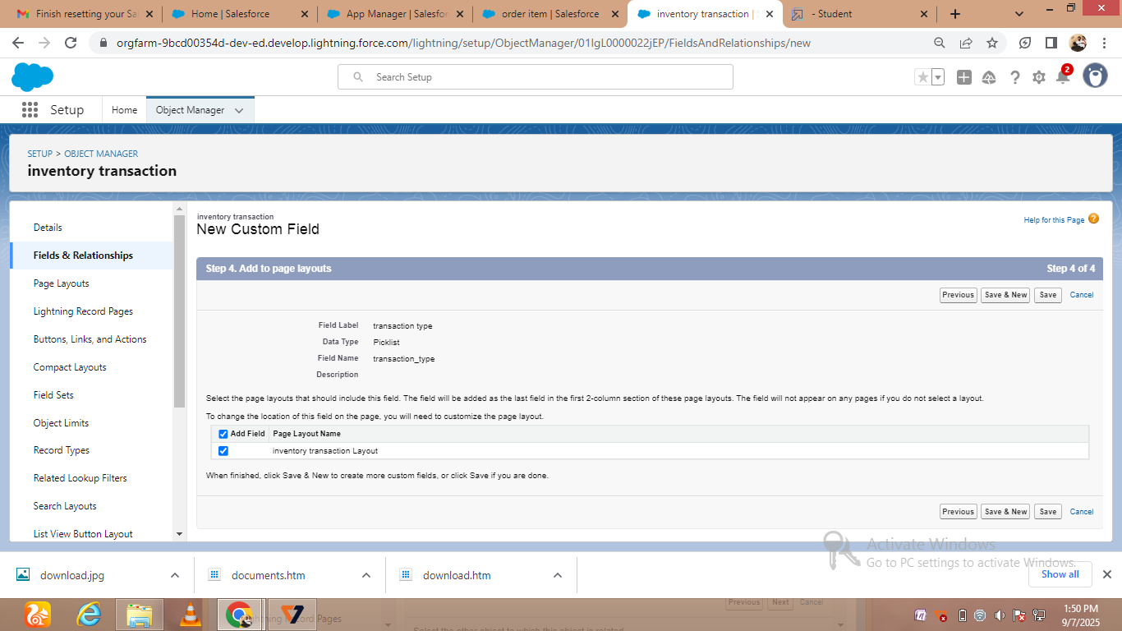

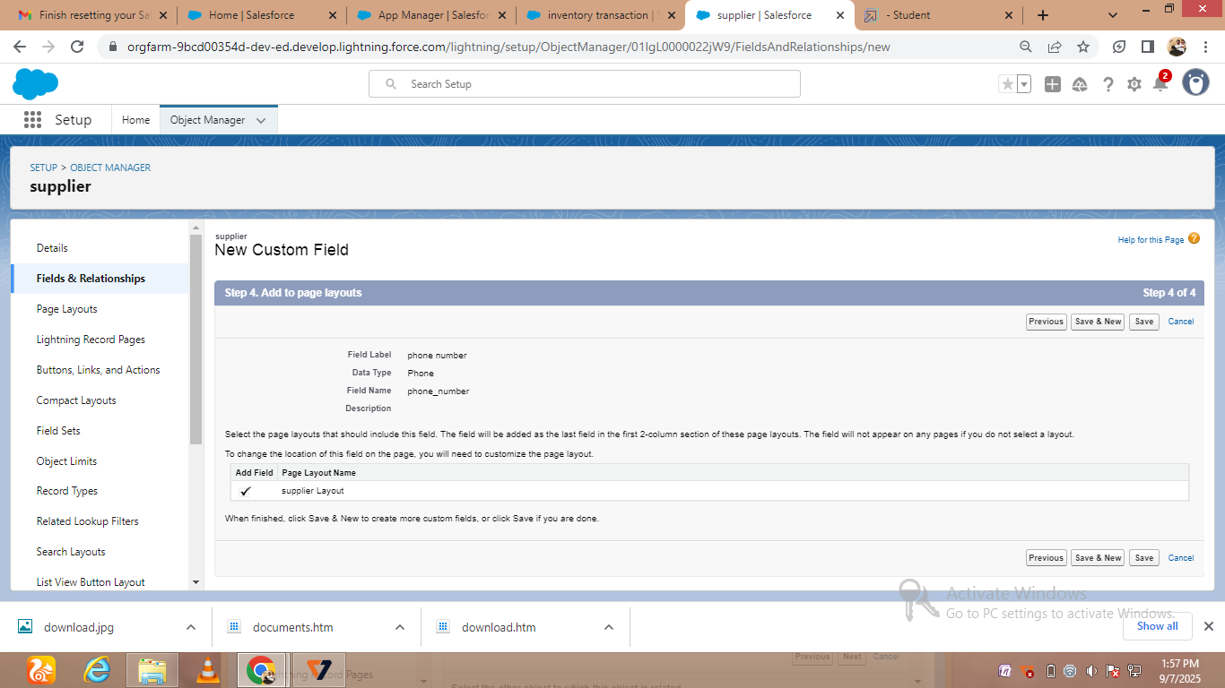

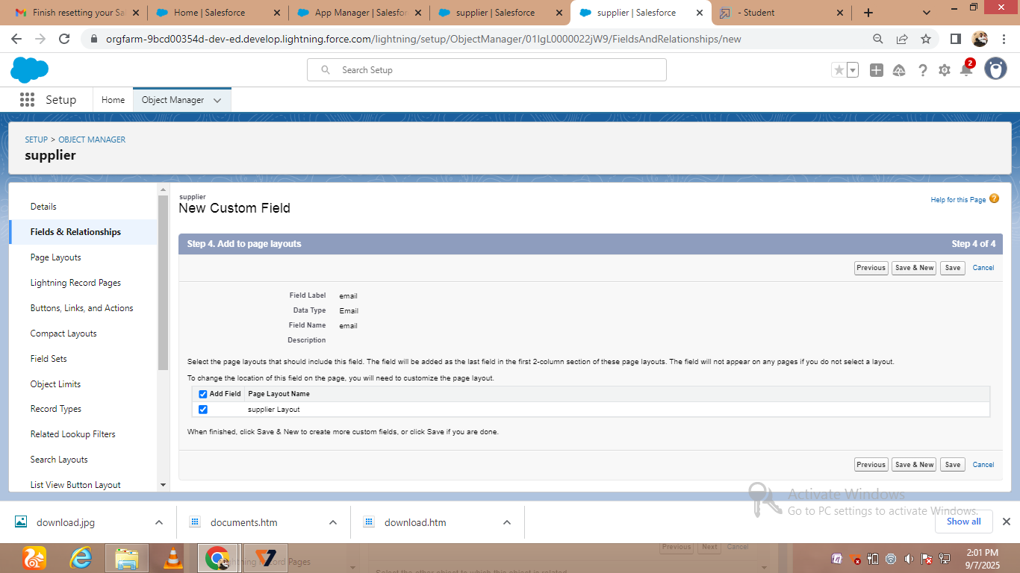

* Creating a customer product

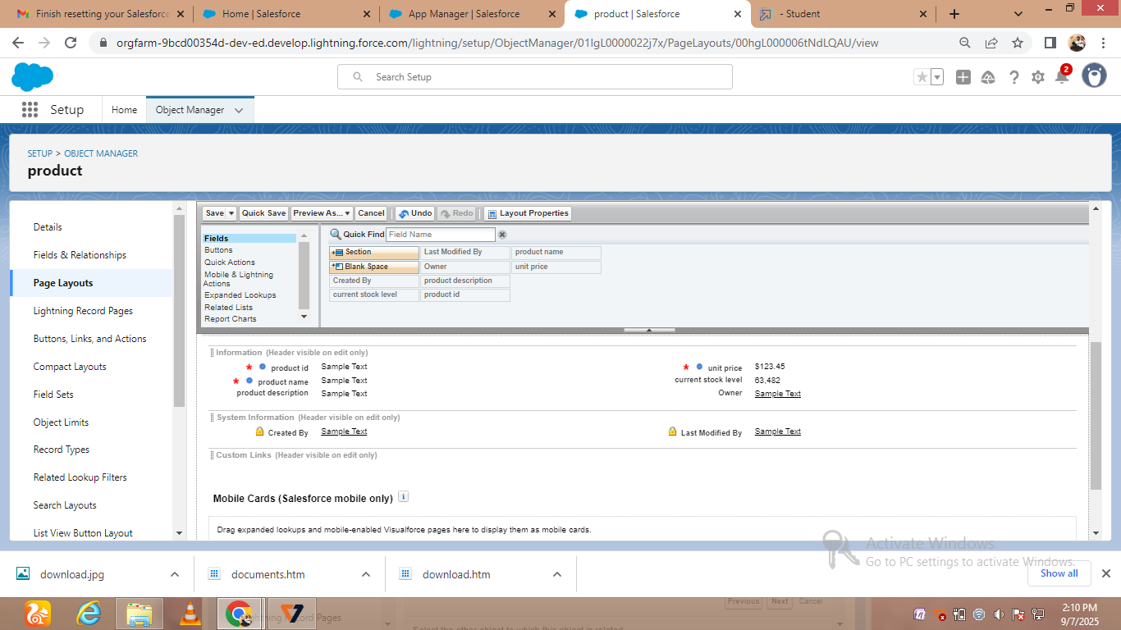

# C:\Users\THIRU\Pictures\Screenshots\Screenshot (26).png

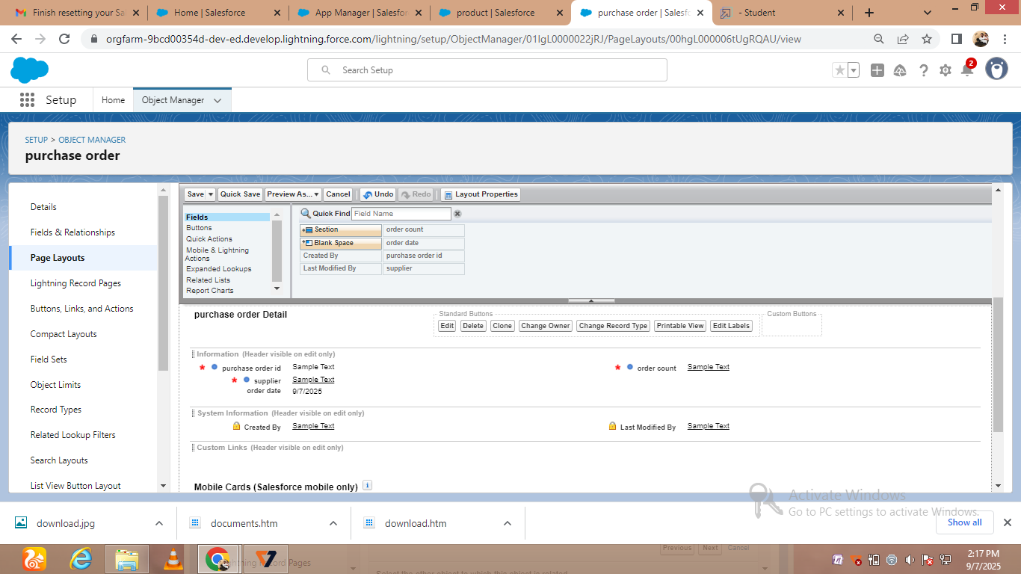

* Creating order item and transaction

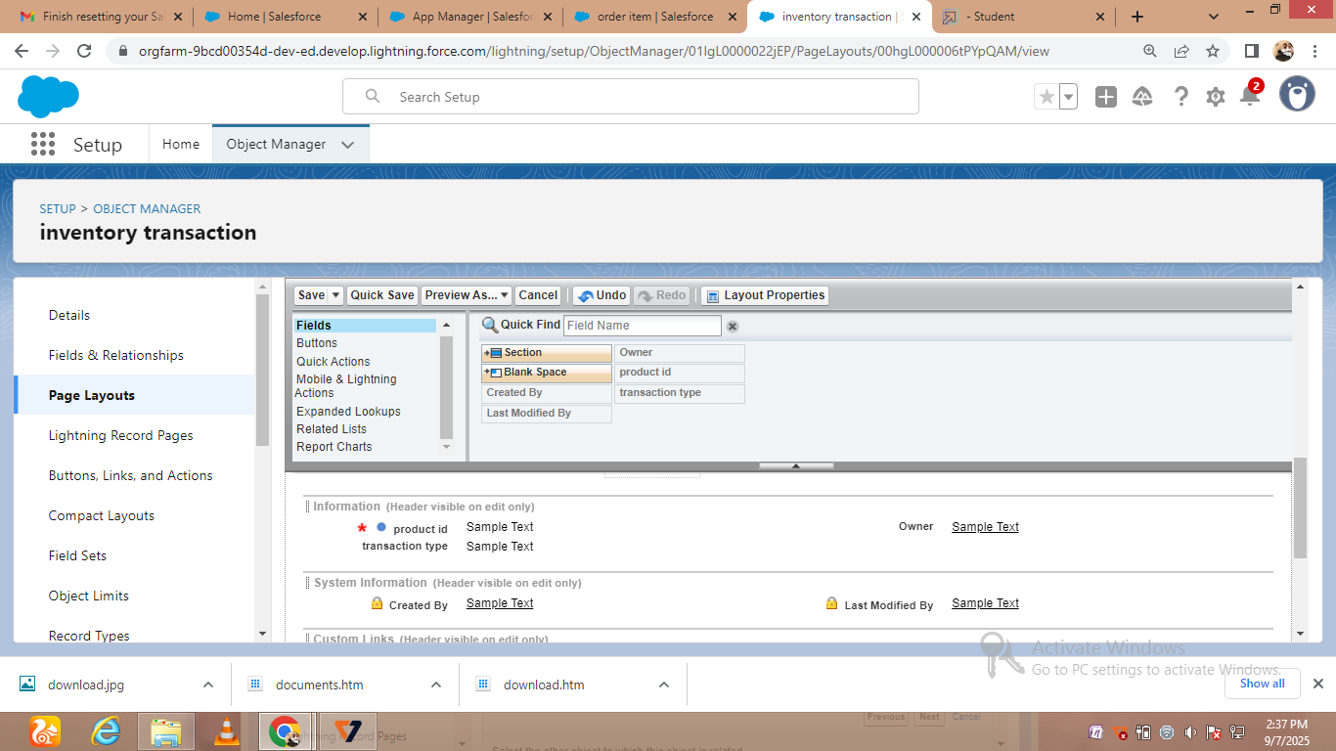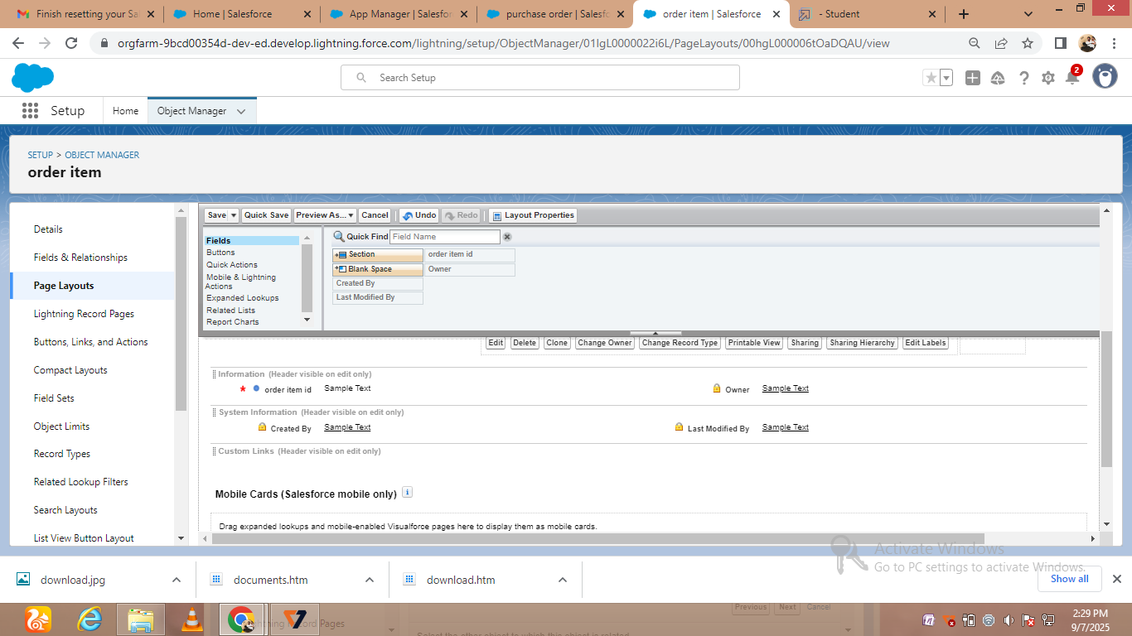



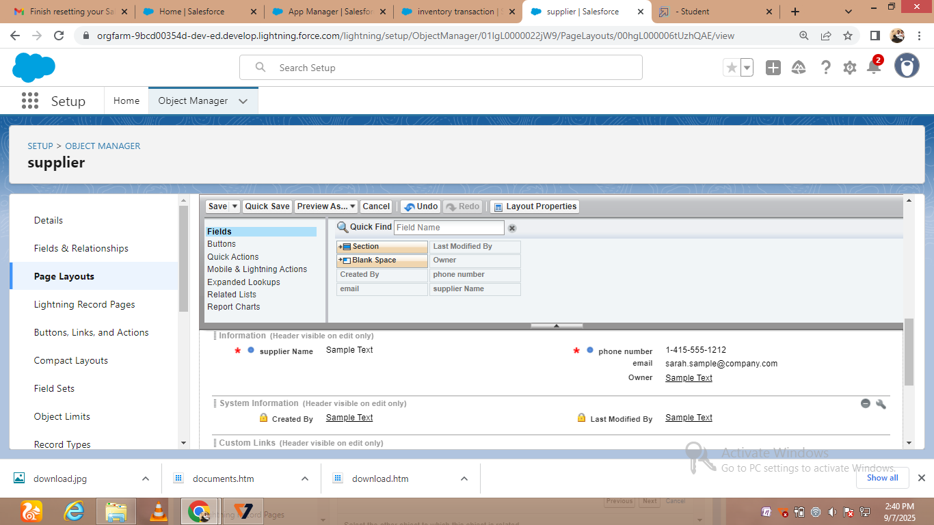

* Creating compact layouts

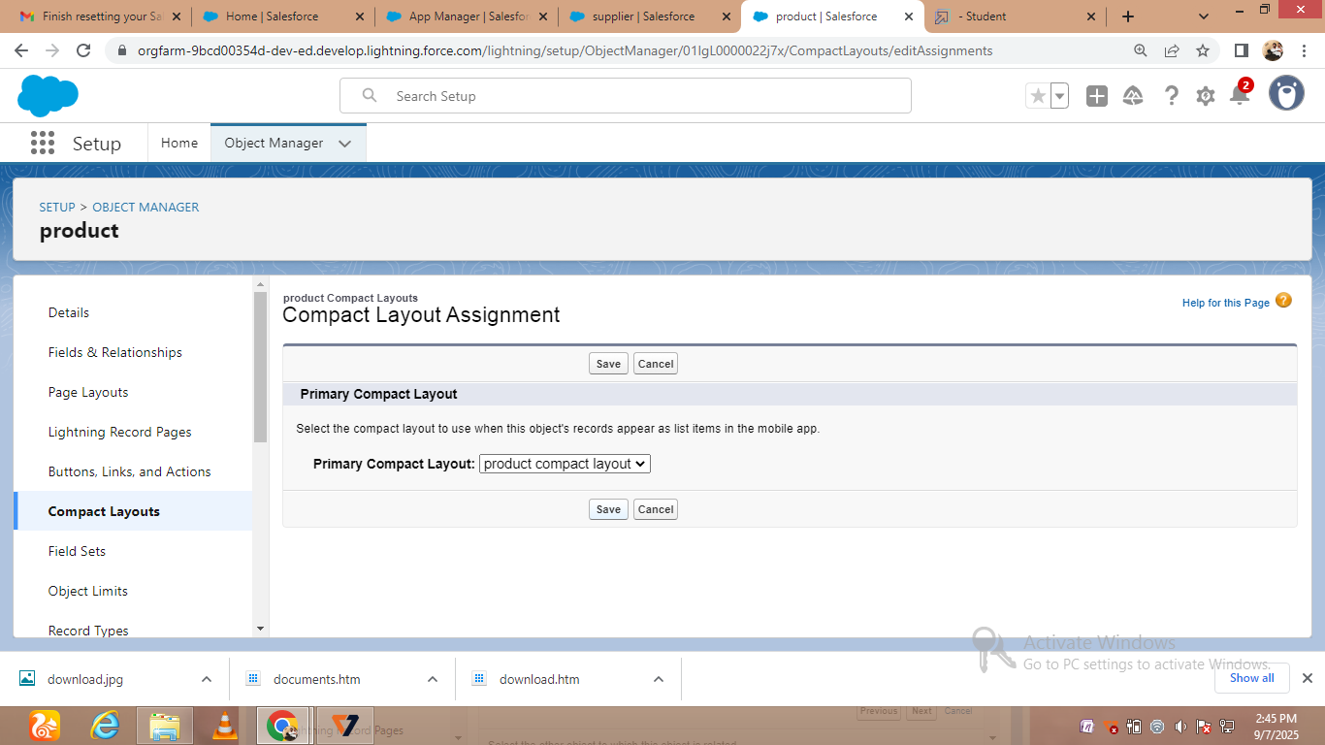 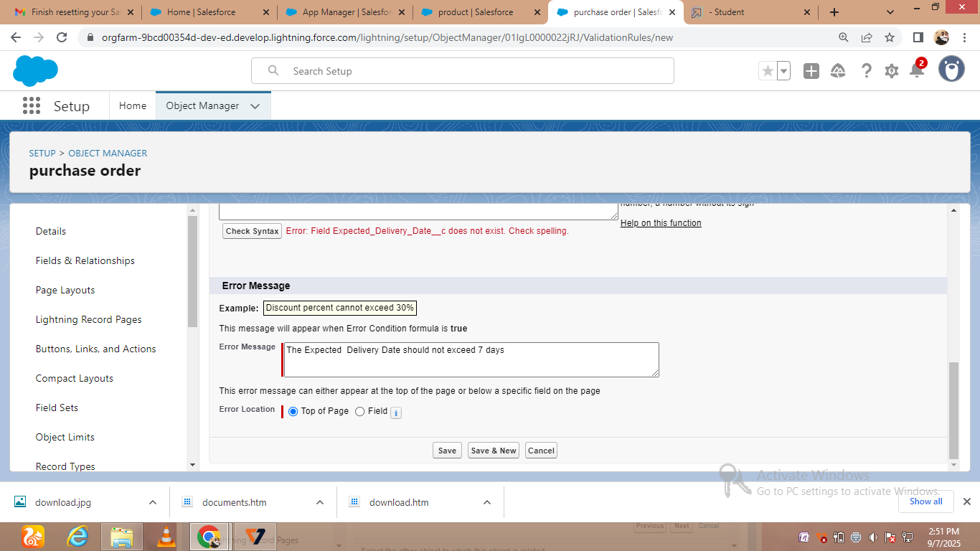

* Creating purchase order validation rule

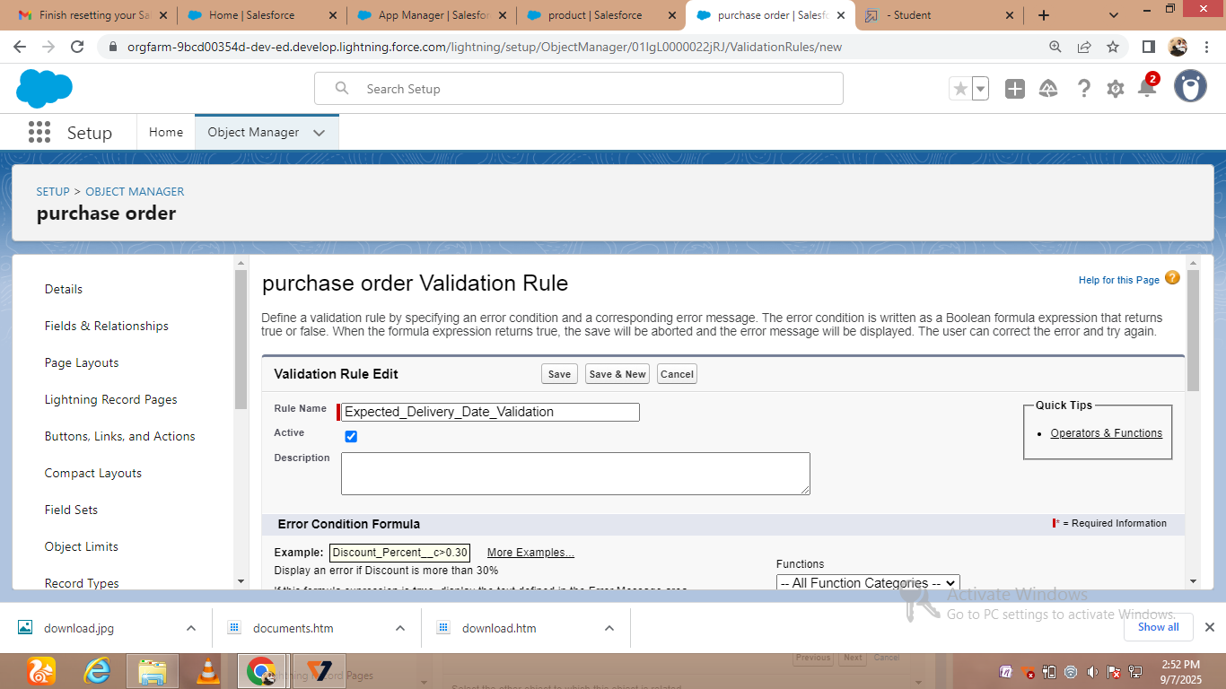

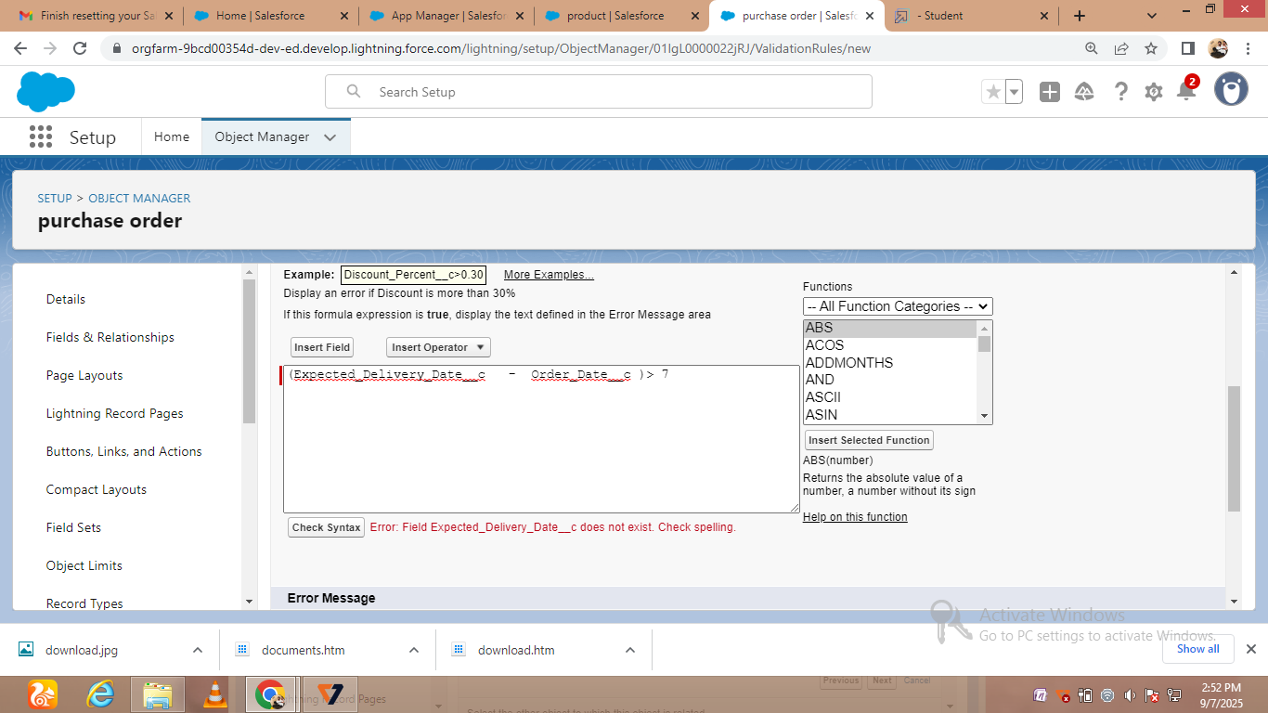



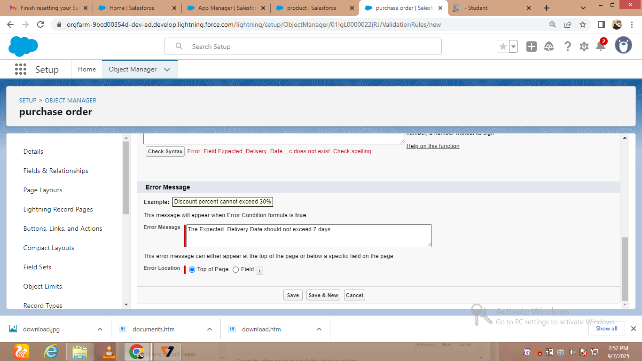

* Creating customer profiles

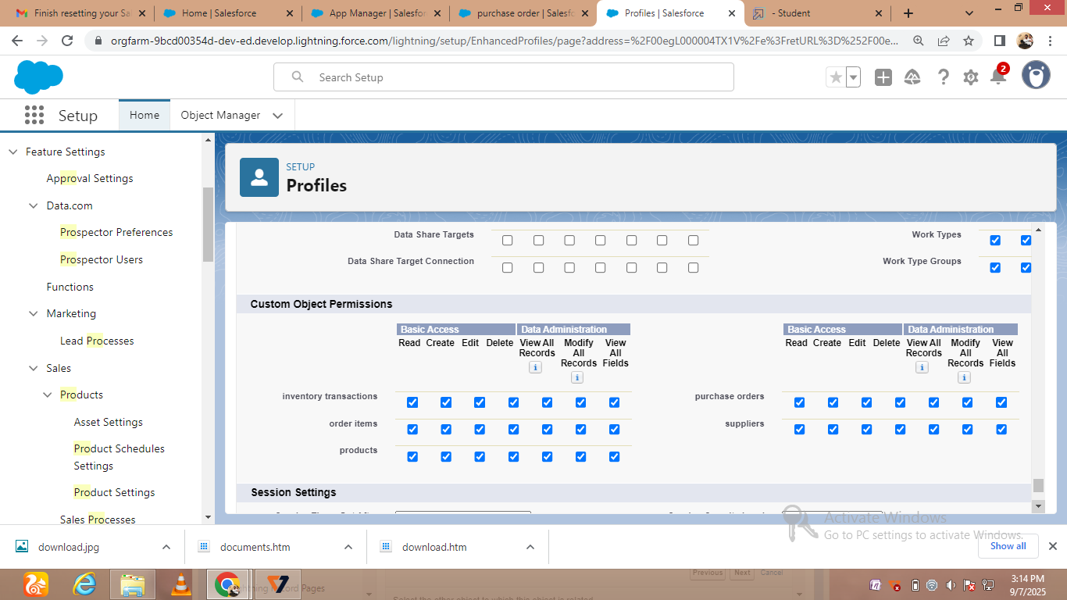

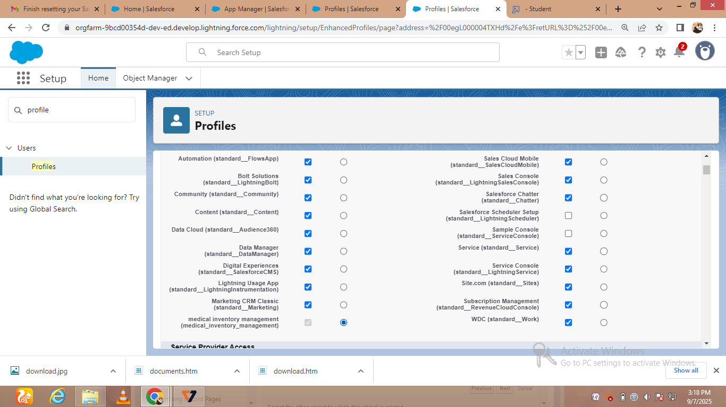

* Creating customer reports

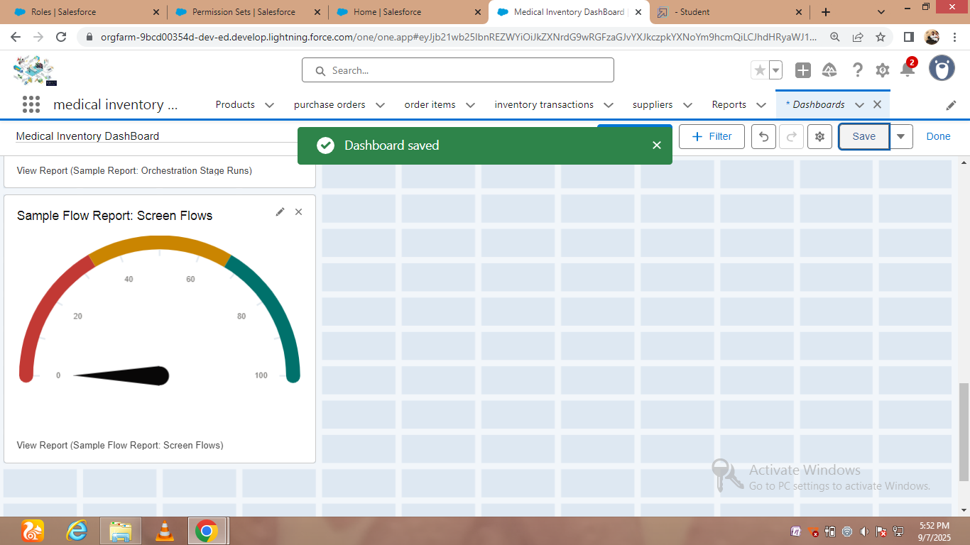

### Conclusion

The Medical Inventory Management system plays a vital role in ensuring the efficient handling of medical supplies, equipment, and pharmaceuticals in healthcare institutions. By automating inventory tracking, streamlining order processes, and maintaining accurate records, the system helps reduce costs, minimize wastage, and improve the availability of critical resources. Furthermore, it enhances decision-making through timely reports and ensures compliance with regulatory standards. Overall, this project provides a reliable and effective solution to optimize healthcare operations, ultimately contributing to better patient care and improved hospital management.